**IMAT3451 BCS Accreditation Checklist**

**Student Name -Mohit Gautam**

**P-number-P15194912**

**Programme-Computer Science**

**Email** - **p15194912@my365.dmu.ac.uk**

**Project Title Restaurant Table Reservation Android App.(Table4Me)**

**Project Proposer**

Mr Mohit Gautam, DMU, Computer science third year student.

**Supervisor**

Dr Richard Bates, Lecturer, School of Computing, [Richard.Bates@dmu.ac.uk](mailto:Richard.Bates@dmu.ac.uk)

**BCS Accreditation**

Your supervisor needs to check your contract against this list and sign if you are on a BCS accredited course. Take note of this and be sure that you mention all requirements.

|  |  |  |  |  |  |
| --- | --- | --- | --- | --- | --- |
| This contract contains an elucidation of the problem, the objectives of  the project and a risk analysis | | | | **Yes** | **No** |
| The contract states that the project will include an in-depth investigation of the context and literature, and where appropriate, other similar products | | | | **Yes** | **No** |
| The contract states that the final report will contain a clear description of the stages of the life cycle undertaken | | | | **Yes** | **No** |
| The contract states that the final report will contain a description of how verification and validation were applied. | | | | **Yes** | **No** |
| The contract states that the report will contain a description of the use of tools to support the development process | | | | **Yes** | **No** |
| The contract states that the final report will contain a critical appraisal of the project, indicating the rationale for any design/implementation decisions, lessons learnt during the course of the project, and evaluation (with hindsight) of the project outcome and the process of its production (including a review of the plan and any deviations from it) | | | | **Yes** | **No** |
| The contract states that there will be a description of any research hypothesis | | | | **Yes** | **No** |
| The contract states that all research will be fully referenced | | | | **Yes** | **No** |
| **Contract is suitable for BCS Accredited Project** | X  **Yes** | **No** | **Supervisor**  **Signature** |  | |

**Student 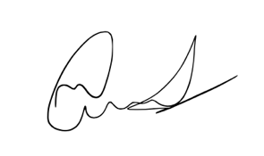 Date 27/10/17**

**Proposer  Date 27/10/17**

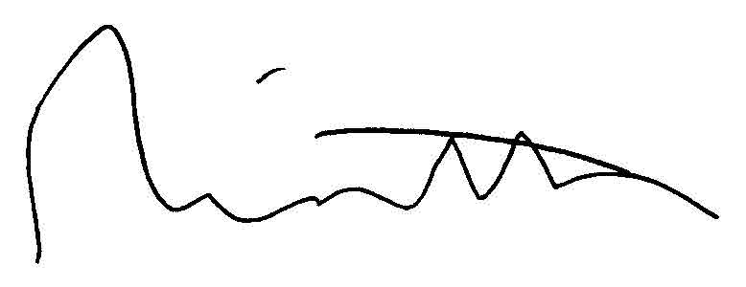

**Supervisor Date 27/10/17**